**Week 15**

On 16 February 2023, I visited an exhibition at the South London Gallery, Bloomberg New Contemporaries 2022, which brought together painting, photography, textiles, installation and sculpture. I was told that the artists in the exhibition were professional artists, graduate students, and recent graduates.

I was very impressed by the religiously distinctive "God has no time for you" (Left figure). This is an illustration by Danying Chen. Three majestic, fierce and even hideous statues of Buddha gaze at a little girl on the side. The little girl looks very weak and powerless, her tears already overwhelming her. The contrast between the dark tones of the Buddha and the lighter tones of the girl is striking. According to the work's description: "Danying Chen user her childhood memories of Buddhist spirituality to explore images of gods and capture desires that are difficult to express."

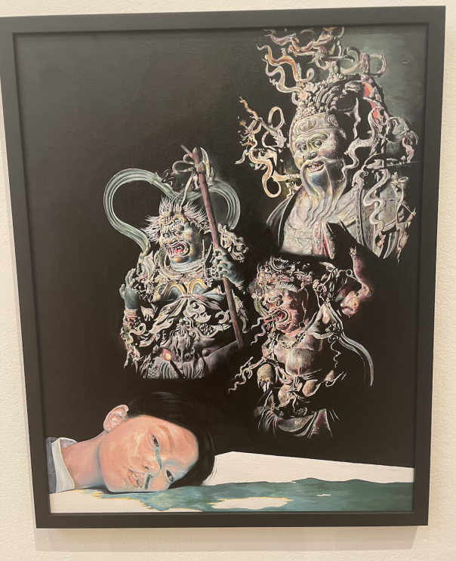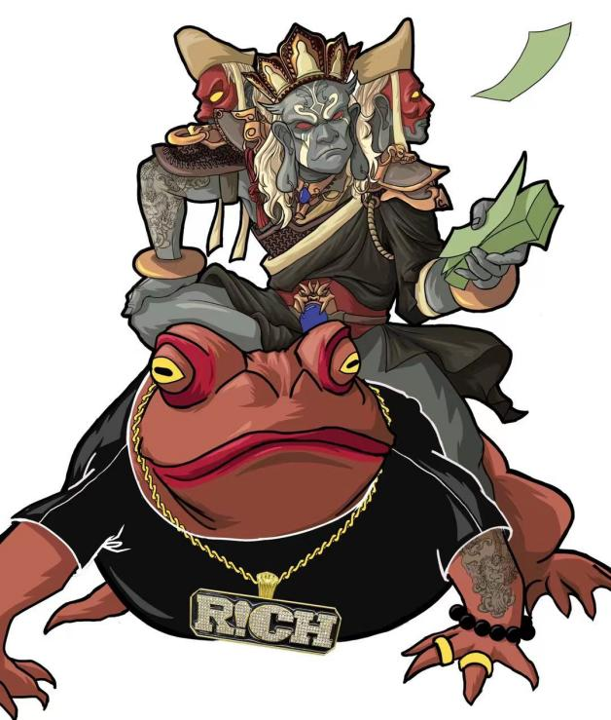

The image of gods is always mysterious and different in everyone's mind. The author portrays her mental image of gods as perhaps slightly hideous through her memories of being a child. My favourite part of this artwork is that it has a very interesting title. "God has no time for you" conveys some irony. Maybe the little girl has prayed religiously, but maybe god doesn't care about you. On the other hand, I would suggest that the author could change this theme to a series of works. I noticed that the three Buddha figures in the painting are different deities. The author could create three illustrations, each with a different name, composition and content. These could be created based on the different character personalities of each god. It would certainly be more interesting.

There are many other artists in this exhibition who also explore the topic of religion, each with their own distinctive characteristics; Akinsola Lawanson chooses to explore religious divination by means of moving images. Theresa Weber has chosen to look at mythology to understand her origins. These works have inspired me to think rationally about the meaning of religion while respecting religion and its followers. During my undergraduate studies, I also created works about religion. The right figure is my work "God of Wealth", an illustration that combines religious culture with modern street culture.

I didn't find any information about "God has no time for you" on the internet, but I did search for the author. Danying emigrated to the UK with her parents from Fujian, China. Her work is inspired by personal experiences of cultural conflict between two environments, and by objects of significance from her childhood, as in 'God has no time for you'. I am a great admirer of this artist.